Streetscape Quality Design Process

SSDM Policy PC.1

Table of Contents

1 Introduction........................................ 3

2 Induction of Schemes into SSDM Quality System................................... 3
2.1 Requesting Induction................................ 3

3 Southwark Highway Scheme Pathways............................................ 3
3.1 Southwark Highway Scheme Pathway Designations............................................ 3

4 Structured Quality Design Process……....................................... 5
4.1 Structured Quality Design........................ 5
4.2 Approval Process…................................ 6
4.3 Southwark Highway Scheme Pathway A Flowcharts................................................. 6
4.4 Southwark Highway Scheme Pathway B Flowchart................................................. 6
4.5 Southwark Highway Scheme Pathway C Flowchart………….................................. 6

5 Design Workshops and Meetings……………………................ 6
5.1 Minimum Number Workshops/Meetings Required……………………………......... 6
5.2 Design Workshop/Meeting Attendees and Materials................................................... 6

6 Departures from Design Standards…….................................... 7
6.1 Types and Levels of Departure………….. 7
6.2 Departure Requests……........................... 7

7 Special Placemaking Opportunities…….............................. 8
7.1 Criteria for Dispensations….…................. 8

8 Quality Plans……………..................... 9
8.1 Purpose of Quality Plans….……….......... 9
8.2 Design Brief Details (Part 1 of Quality Plan)………………................................... 9

9 Scheme Submission Requirements……….......................... 9
9.1 Design Brief Detail Requirement……….. 9
9.2 Works Limit Plan…………........................ 9
9.3 New Highways Extents Plan……….......... 10

9.4 Document Submittal for All S278 and
S38 Schemes.…………............................ 10

10 Performance Assessment Reports (Pathway A Only)................................ 10

11 Continuous Improvement….............. 10

Appendix A
Southwark Highway Scheme Pathway A Outline Design Flowchart……………………. 11

Appendix B
Southwark Highway Scheme Pathway A Detailed Design Flowchart…………………… 13

Appendix C
Southwark Highway Scheme Pathway B
Design Flowchart……………………………… 14

Appendix D
Southwark Highway Scheme Pathway C
Design Flowchart……………………………… 15

Appendix E
Document Submission Requirements for
all S278 and S38 Schemes………………….. 16

1 Introduction

This text explains the Highway Authority’s standing order Procedure requirements for progressing Schemes through the Southwark Streetscape Design Manual (SSDM) Quality System.

Induction into the Quality System is a mandatory requirement for Schemes to create or modify Highways. The only exceptions to this are works by Statutory Undertakers (public utility companies) to maintain or lay services and minor, like-for-like repair or reinstatement ‘point works’ by Highway Authority managers to existing highway assets (e.g. correcting pot holes and rocking flags or repairing or straightening street furniture).

The Approving Officer will clarify which Pathway A, B or C will be followed. Pathways are designed to reflect the difference in complexity and needs for levels of design information between different types and sizes of scheme.

The number of meetings required for a complex Pathway A scheme will be dependent on the scheme. For Pathway B schemes it is recommended to hold two meetings to review design, agree departures, identify consultations, safety audit requirements and possible Traffic Management Orders.

Unless a Departure as per this Procedure is requested and Approved then the requirements of SSDM/DSR Design Standards must be followed. All Departures will be agreed with the Approving Officer assigned to each Scheme.

Special Placemaking Opportunities (SPO) Dispensations may be Approved to support the delivery of more bespoke design proposals within small, well-defined areas of streets and spaces. The emphasis of any SPO will be that the proposal will create a better scheme than that possible with the SSDM requirements.

Quality Plans will be required for all schemes. However, Pathway C schemes only need to complete Part 1 of the Quality Plan, and Pathway B schemes will be reviewed by the Approving Officer to decide if Part 2 of the Quality Plan is required.

2 Induction of Schemes into SSDM Quality System

2.1 Requesting Induction

Any proposed Scheme to create or improve a Highway needs to be captured on the SSDM Quality System. The information required only needs to be very basic about the nature of the envisaged works. No significant design proposal drawings are required at this time.

Each Scheme description should consist of works within a single contiguous site (though this may be a statutory zone such as a 20mph zone or controlled parking zone if this is logically related to the Scheme objectives/ends). However, including multiple sites within a single constitutional Ward or Community Council area may be permitted for very minor Schemes (For instance, introducing pedal cycle parking stands in multiple locations around a Ward).

The information provided will be used to enter the new Scheme into the Highway Authority’s Scheme Database as a Proposal. This is to assist the Highway Authority deliver its statutory duty to coordinate works in the Highway.

Once the Scheme has been accepted onto the database, the Approving Officer will be assigned to the Scheme and the Scheme reference number issued. The Approving Officer will contact the Main Contact for the Proponents to arrange a meeting to discuss next steps and clarify any aspects of the Quality System that the Proponents may be uncertain about.

3 Southwark Highway Scheme Pathways

3.1 Southwark Highway Scheme Pathway Definitions

Depending on the size and complexity of the proposed scheme, there are three pathways through the SSDM Quality process. These pathways simplify the process for less complex schemes. See Table 1 below.

Pathway | Scope of likely appropriate schemes

A | - Schemes that include the creation of any new street or new highway.  - Schemes that include the creation or enlargement of public spaces in either existing or new streets.  - Medium-large comprehensive improvement schemes that involve substantial changes to existing street geometry.
B | - Internal program-based asset renewal works which involve minor improvements / changes rather than just like for like renewal.  - Internal program-based asset renewal works to pavements, lighting, trees etc.  - Point based improvements that are more technically / statutorily complex e.g. zebra crossings, "floating" bus stops.  - Simple, clearly defined developer improvements (Majority of S278/S38 works).
C | - Minor isolated changes to waiting and loading restriction or access prohibitions (and associated TMOs) that require no physical changes other than to signs and road markings.  - Very simple point works or program-based internal asset renewal works. Typically in response to minor local issues raised by the public or elected members, including via Cleaner Greener Schemes (CGS).
Table 1. Scope of works appropriate to each Pathway.
Each Pathway definition has design information that must be provided as part of the design process. However as the complexity of the schemes decrease from Pathway A down to Pathway C, the required design information decreases too. The implications for each Pathway are described in Table 2 below. Reactive repairs identified through the inspection and repair service (potholing/flagging etc.) and works by statutory undertakers are not included in this process.

Implications |  | Pathway  A | Pathway  B | Pathway  C
Entry onto Schemes Spreadsheet required |  | ✓ | ✓ | ✓
Schemes to be part of a group |  | (✓) | (✓) | (✓)
Scheme Certificate required |  | ✓ | ✓
Performance assessment reports (PARS): required to confirm success at achieving objectives/thresholds |  | ✓
Quality Plan Components | Objectives: the fundamental objectives of the scheme. Some may be identified as priority or compulsory. | ✓ | ✓
 | Success thresholds: Describe what constitutes success in achieving the objectives at different levels. Basis for later performance assessment (if required). | ✓
 | Monitoring indicators, surveys and assessments: Where required, used to define the success thresholds in greater detail. | ✓
 | Proposed Physical Measures (PPMs). These are broadly defined design approaches that teams must attempt to incorporate into their proposals to deliver particular objectives. They are discharged if it is shown they are not feasible/desirable. | ✓
 | Compulsory Works: *New* These are very well defined design improvements that must be incorporated into proposals. | (✓) | ✓ | ✓
 | Works limit plan: Defines the maximum area in which standards must be complied with. | ✓ | ✓ | ✓
 | New highway extents plan (only if new streets are proposed): confirms minimum street widths, alignments and access points for new streets. | (✓) | (✓)
 | Funding: Details to be included in the relevant columns of the scheme spreadsheet. | ✓ | ✓ | ✓
 | Program List: Spreadsheet that allows multiple schemes to be inducted at once for program based renewal works and the like. It then also serves as their quality plan and scheme certificate (the later not being produced for those schemes). |  |  | ✓
Ticks in brackets mean this item is to be complied where applicable.
Table 2. Required information for each Pathway.
4 Structured Quality Design Process

4.1 Structured Quality Design

The SSDM Quality System stages are described in Table 3 below.

Phase | Workstage | Mandatory  for Pathway
Proposal | Conduct a meeting to review the proposal and for the Approval Officer to assign the appropriate SSDM Scheme Pathway. | A and  B where applicable
Outline  Design | On completion of the outline design a review will be undertaken to:  - Review the design to confirm suitability of the scheme  - Agree any Departures from Design Standards  - Carry out Public Consultation activities and RSA/ACA site visits if applicable.  - Stopping Up: Where relevant, agree Stopping Up proposals for consultation. | A and  B where applicable
On completion of the outline design review the detail design can be undertaken.

Typical items of work to be undertaken during the detail design. The following is an indicative list only.

- Carry out Public Consultation activities and RSA/ACA site visits if applicable.
- Issuing responses to RSA/ACA Audit Reports if applicable.
- Approve final version of the Quality Plan
- Submit information for statutory/ constitutional consultation on Traffic Management Orders (TMOs) and/or Stopping Up proposals.
- Review consultation responses. Agree minor modifications to the Detailed Design Proposal Package Approved.
- Confirm the Order(s).
- Undertake on submission of final detail design a comprehensive design review.
- Approve the final Detailed Design Proposal Package for progress to construction.

Detailed
Design
A and
B where applicable
Construction | On approval to go to construction the following are typical items of work to be undertaken. The following is an indicative list only.  - Obtain ‘before’ data for monitoring purposes in advance of the start of works.  - Approve various work management plans. (Traffic management plans etc.)  - Construct the works and carry out associated inspection / supervision activities.  - Snagging Self Assessment by the Contractor and  - Agree snagging issues and any modifications identified in the RSA to be addressed immediately and the ‘watch’ items that can be monitored. | A and  B where applicable
Handover and Close Out | On completion of the Maintenance period the following are typical items of work to be undertaken. The following is an indicative list only.  - Carry out any monitoring data collection activities and RSA/ACA site visits.  - Under take final snagging inspection.  - Agree adjustments to the constructed works / snagging issues.  - Agree adjustments to the Maintenance Plan  - Implement and sign-off any snagging actions/ adjustments to the constructed works that need to be addressed. | A and  B where applicable
In Use | If applicable on completion of the 36 Month Post-Completion the following are typical items of work to be undertaken. The following is an indicative list only.  - Carry out any monitoring data collection activities and RSA/ACA site visits.  - Agree any remaining adjustments to the constructed works /snagging issues.  - Implement and sign-off any remaining snagging actions/adjustments.  - Hand over the Health and Safety File. | A and  B where applicable
Table 3. Southwark Quality Design Process
The main purpose of the Design Process is to ensure a structured approach to the development, review, approval, construction and monitoring of Schemes to create or improve Highways. This helps provide certainty for all interested parties and assists in good project management. The sequence of intervals is based on a logical arrangement of tasks and activities that need to be completed before latter ones can be reasonably commenced.

In order to ensure that the process is followed and the activities in each interval are completed, the work phases as shown in Table 3 need to be followed.

4.2 Approval Process

On the completion of each of the stages as shown in Table 3 above, the consultant/developer will produce a set of minutes of the meeting in which all the relevant details are captured and agreed.

If so required, any departure certificates will be approved and signed off by the Approving Officer.

A letter of approval of the construction drawings for all highway works will be issued by the Approving Officer after completion of the design review process.

4.3 Southwark Highway Scheme Pathway A Flowcharts

Appendix A describes the Outline Design process for Pathway A schemes.

Complex schemes that follow Pathway ‘A’ will have to go through both Outline Design (or Outline design) stages as well as Developed/Technical design (or Detailed Design) stages.

Appendix B describes the Detailed Design process for Pathway A schemes:

4.4 Southwark Highway Scheme Pathway B Flowchart

Less complex schemes that follow Pathway ‘B’ do not have to go through the Outline design stage. Generally they can progress to the Developed/Technical design (or Detailed Design) stages after the Preparation and brief has been accepted.

Appendix C describes the Design process for Pathway B schemes.

4.5 Southwark Highway Scheme Pathway C Flowchart

Pathway C schemes are by definition, minor works with clear objectives, using established construction methods. Provided the schemes are inducted onto the Schemes spreadsheet for coordination purposes and a works limits plan is produced, only part 1 of the quality plan is required.

Appendix D describes the Design process for Pathway C schemes.

5 Design Quality Workshops and Meetings

5.1 Minimum Number Workshops /Meetings Required

The number of meetings that take place for a complex Pathway A scheme will be dependent on the scheme. The following are possible meetings that can take place:
i. Design workshop to discuss draft design drawings and departures.
ii. Design workshop to discuss detailed design submission.
(See Appendices A and B for when these meetings should occur in the scheme design process.)

For Pathway B schemes it is recommended to hold two meetings; the first to discuss draft design, agree departures, identify consultations, safety audit requirements, possible Traffic Management Orders; and the second meeting to discuss detailed design, consultation results and any necessary amendments. (See Appendix C for when these meetings should occur.)

Pathway C schemes do not require a mandatory meeting, but can benefit from workshops if there are issues that need resolution.

5.2 Design Workshop / Meeting Attendees and Materials

The Approving Officer and the Main Contact for the scheme as minimum attendance, but it is usual for the design engineer and the project manager for the scheme to also attend. The Approving Officer or Project Manager may invite other council officers to attend if they have relevant input (e.g. tree officers or the Traffic Manager). Similarly, the Main Contact may invite key staff (e.g. contractor/ site foreman, design engineers).

The proponent/project team is requested to bring copies of their design to the meeting together with plans and such other information as may be necessary to reasonably inform discussions. It is recommended that copies of this information are provided to the Approving Officer and Project Manager three days before meetings so that meetings are more productive.

6 Departures from Design Standards

6.1 Types and Levels of Departure

Departures will only be accepted when all design possibilities have been exhausted. It is incumbent on the designer to demonstrate that there are no other options and the departure is required. All departures will be formally submitted for review.

There are two types/levels of Departure that may apply:
i. Basic Level 1 Departure:
This is the most common departure, typically required where there is a viable alternative, but the Highway Authority wishes to avoid or restrain that alternative (e.g. use of many road signs and markings). The council’s officer appointed to the scheme can review and approve these basic departures. The majority of SSDM requirements are of this level and the process is very simple. All that is required is for the Project Team to demonstrate to the Approving Officer that:
    - the proposed Departure is sensible
    - any noted conditions that may be explained in SSDM/DSR Design Standards are satisfied.
The council’s officer appointed to the scheme is responsible for retaining information within the Scheme File for future internal audit.

ii. Basic Level 2 Departure:
These departures are reserved for things considered undesirable by the Highways Authority and only likely to be appropriate in exceptional circumstances (other approaches being strongly favoured). They are more complex in nature and involve a number of stakeholders or interested persons. The Group Manager will be responsible for all Level 2 departures. This Level of departure is often indicated by the phrase “should” or “should not” in the Design Standards (e.g. in the event it was stated that “this method of Construction should not be used” or “ minimum width of 1.8m should be provided” then a Level 2 departure is required). As for Level 1 departures the Project Team will have to convince the Group Manager that there are no other options and the departure is required.

Southwark Council will keep a log of all agreed departures. It will be reviewed annually as part of our continual improvement process. If it becomes apparent that a specific departure is often approved, then this information may be used to inform the need to amend our Design Standards accordingly.

6.2 Departure Requests

Departure requests must be submitted and agreed in advance of the submission of design proposal information.

The earliest point in the Development Process at which Departure requests may be made and determined is during the Outline Design workshop.

Departure requests are specific to individual Schemes. Departures may not be requested, and will not be approved, for multiple Schemes at once.

SPO Departures are rare and may only be made if a Special Placemaking Opportunity Dispensation has been approved for the part of the Project Area to which the request relates; consequently they are not shown on the departure form. However, the Approving Officer may be contacted for advice on how to amend the form to submit an SPO Departure.

Similarly, Design Pilot Departures may only be requested if a Dispensation has been approved or instructed during proposal Briefing meeting for the part of the Project Area to which the request relates.

When a formal Level 1 Departure is requested, applicants should try to anticipate the likely concerns of Approving Officers. SSDM/SER Design Standards will often note conditions that must be demonstrated if departures are requested, or circumstances in which requests are likely to be met favourably.

Level 2 Departures require the following to be submitted:
i. Detailed description of why the Departure is required.
ii. Detailed description of the variance from the SSDM requirement.
iii. Drawing showing the SSDM requirement and the proposed departure requirement.

Requests and Approvals for both Level 1 and Level 2 Departures may relate to more than one SSDM design requirement at a time provided they relate to a single coherent issue and must be logically indivisible from one another. Approving Officers have discretion to reject submissions if they reasonably consider that they contain multiple unrelated requirements.

The justification for Basic Level 2 Departures are limited to:
i. Construction feasibility (excluding cost).
ii. Cost to the Council.
iii. Network Management impact.
iv. Road safety.
v. Maintainability.
vi. Accessibility (e.g. for vulnerable pedestrians).

If a SPO Dispensation applies such that a SPO Departure can be made then requests may also be justified using the following further grounds:
i. Visual amenity.
ii. Benefit to social interaction.

A submitted Level 2 Departure request is reviewed by the Group Manager. The Applicant will be contacted to confirm whether the submission is Accepted or Rejected via email or other correspondence. Where information is found to be unacceptable, the submission will be returned to the Applicant as rejected.
If the departure is approved, the appropriate Departure Approval certificate will be provided to the project team.

If circumstances change to the extent that the justification for the Departure ceases to exist, the Departure Approval may be revoked by the Group Manager. An appeal may be made by the applicant to the Head of Highways.

Where relevant, the Approving Officer may require commuted sums or internal charges to be paid to cover the additional costs to the Highway Authority that are likely to be borne as a result of the approved departure.

7 Special Placemaking Opportunities (SPOs)

7.1 Criteria for Dispensations

Special Placemaking Opportunities (SPO) Dispensations may be approved to support the delivery of more bespoke design proposals within small, well defined areas of streets and spaces. The emphasis of any SPO will be that the proposal will create a better scheme than that possible with the SSDM requirements.

SPO Dispensations may be proposed by either Proponents or internal Planning and Regeneration Officers. From time to time, Approving Officers may also suggest to the above parties that they consider proposing Dispensations.

SPO Dispensations may only be Approved during the Outline design meeting with Highways/Transport officers. This is to ensure that all parties consider the programme and cost.

The detail of each Dispensation must be recorded in the Project’s Quality Plan, and include:
i. Spatial extents of the Dispensation. This is defined on the Works Limit Plan.
ii. Special Objectives that will delivered and the Potential Physical Measures through which it is initially proposed to achieve these.
iii. Associated Monitoring Indicators that will be used to evaluate the success in achieving the Objectives.

If an SPO Dispensation is Approved then the following additional requirements apply:
i. Mandatory inclusion of Outline Design Workstages.
ii. Preparation of a minimum of three Outline Design options.
iii. Mandatory inclusion of additional Design Workshops. These Workshops will inform the agreement of the design proposals as well as snagging and monitoring following implementation.
iv. All Departures to be subject to Final Confirmation at the end of Detailed Design when it can be confirmed that the SPO related Objectives committed to, have been fundamentally delivered.
v. Additional Approving Officer fees to cover additional Approving Officer involvement.

The Head of Highways may revoke approved SPO Dispensations if it becomes clear that the project team are not acting to deliver the related SPO objectives or it is accepted that delivering the agreed objectives is no longer viable due to a fundamental change in constraints or other key scheme influences.

8 Quality Plans

8.1 Purpose of Quality Plans

The purpose of a Quality Plan is to confirm for each Project:
i. Spatial boundaries
ii. Objectives.
iii. Indicators that will be used to measure how successful the above objectives are.
iv. Matters that are out of scope and therefore do not need to be addressed by design proposals,
v. Potential Physical Measures (or PPMs).
vi. Access points, alignments and minimum widths for new streets and spaces.

A full Quality Plan (both Part 1: Design Brief and Part 2: Monitoring Plan) is required for Pathway A schemes. Pathway B Schemes will be reviewed by the Approving Officer to decide if the objectives of the scheme require a Monitoring Plan (Part 2 of the Quality Plan). Only the Design Brief (Part 1 of the Quality Plan) is required for Pathway C schemes.

8.2 Design Brief Details (Part 1 of Quality Plan)

This requirement is used to confirm the following information:
i. Potential Physical Measures (PPMs)
PPMs are physical interventions that the Project Team must consider to deliver particular agreed Objectives. They must be mutually agreed between the parties. If a Special Placemaking Opportunity Dispensation is approved for a part/s of the Project Area then any PPMs relating to these must be separately stated. PPMs are normally only specified for areas within the existing adopted Highway.
ii. Design Matters that are Out Of Scope
This section is used to state any Design Matters that it is exceptionally agreed to exclude from the scope of the improvements that must be carried out within the Project Area. These Matters are referred to as Out Of Scope. The practical consequence of a Design Matter being Out Of Scope is that requirements in SSDM/DSR Design Standards associated with it do not then need to be met.

9 Scheme Submission Requirements

9.1 Design Brief Detail Requirement

This requirement is used to confirm the following information for Pathway A, and if required, for Pathway B (see section 8.2 above):
i. Objectives.
ii. Potential Physical Measures (PPMs)

9.2 Works Limits Plan

This Plan should confirm the following information over an OS base map scaled at 1:500 or closer:
i. Project Area
This is the minimum area(s) within which it is agreed the Project will carry out improvement works. On a case specific basis the Project Team may also be required to carry out minor works outside of the Project Area to facilitate works within it. Examples include updating zonal traffic signs or speed limit signs due to changes affecting Traffic Management Orders and Speed Limit Orders within the Project Area.
ii. Special Placemaking Opportunity (SPO) Dispensation
If a SPO Dispensation is Approved for a part/parts of the Project Area then the spatial limits of this must be identified. The reference code and name for that Dispensation must also be stated.
iii. Design Pilot Dispensation
If a Design Pilot Dispensation is Approved for a part/parts of the Project Area then the spatial limits of this must be identified. The reference code and Subject of that Pilot must also be stated.
iv. Areas associated with Design Matters that are Out Of Scope
If it has exceptionally been agreed that certain Design Matters are Out Of Scope within parts of the Project Area then those locations may be identified for clarity, but this is not mandatory.

9.3 New Highway Extents Plan

This Plan is only required if the Project will include any:
        - Proposed new Highways.
        - Proposed new accesses from the existing Highway (including Vehicle Crossings).

This Plan must confirm the following information over an OS base map scaled at 1:500 or closer:
i. The location of new points of access to new streets and spaces from the existing Highway and any proposed Vehicle Crossings from the same.
ii. The centreline alignments of new streets and spaces.
iii. The minimum widths of new streets and spaces.

Any dimensions required on this drawing should be correct to the nearest centimetre and will be taken as such when interpreting the information in future.

9.4 Document Submittal for all S278 and S38 Schemes

Appendix E details the complete submission requirement. Please Note: On reviewing the submission, if any of the listed documents are missing then the submission will be rejected; unless it has been agreed with the approving officer that some documents may be omitted for smaller schemes.
10 Performance Assessment Reports (Pathway A Only)

The purpose of each Performance Assessment Report (PAR) is to evaluate the success of design proposals or constructed works in achieving the agreed Objectives in the Quality Plan for a Project. In doing so, PARs encourage continued focus by all parties on adherence to Quality Plans. PARs are concerned only with delivery of agreed Quality Plan Objectives.

The evaluation of how successful the design proposals and constructed works are in meeting the individual Quality Plan Objectives are:
i. Scoring each proposal/works in achieving the Objective as follows:
- A – Objective substantially exceeded
- B – Objective met
- C – Objective partly met
- N –Objective not achieved

ii. Justification:
The assessor must provide justification for the score they have assigned.

iii. Reasons for failure/shortfall
If an Objective has been scored as either C (Objective partly met) or N (Objective not achieved) then the reasons for the shortcoming must be explained and justified.

11 Continuous Improvement

The Head of Highways will undertake an annual review of the following items to check conformity with this procedure:
i. A sample of Quality Plans and associated documents.
ii. A sample of Departure Requests and determinations.
iii. A sample of PARs.

The Standing Order Procedure will be reviewed annually by the Head of Highways and updated where appropriate.

Appendix A Southwark Highway Scheme Pathway A Outline Design Flowchart

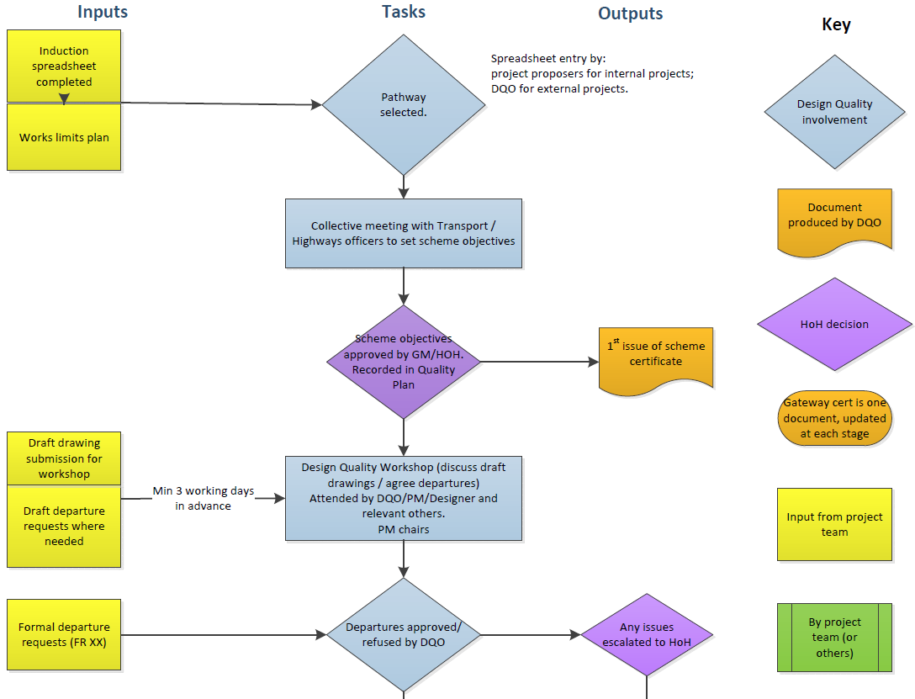
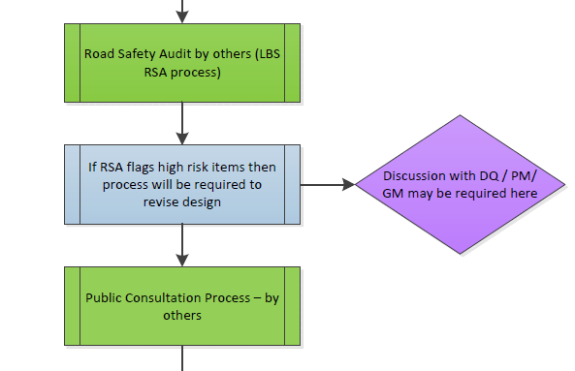
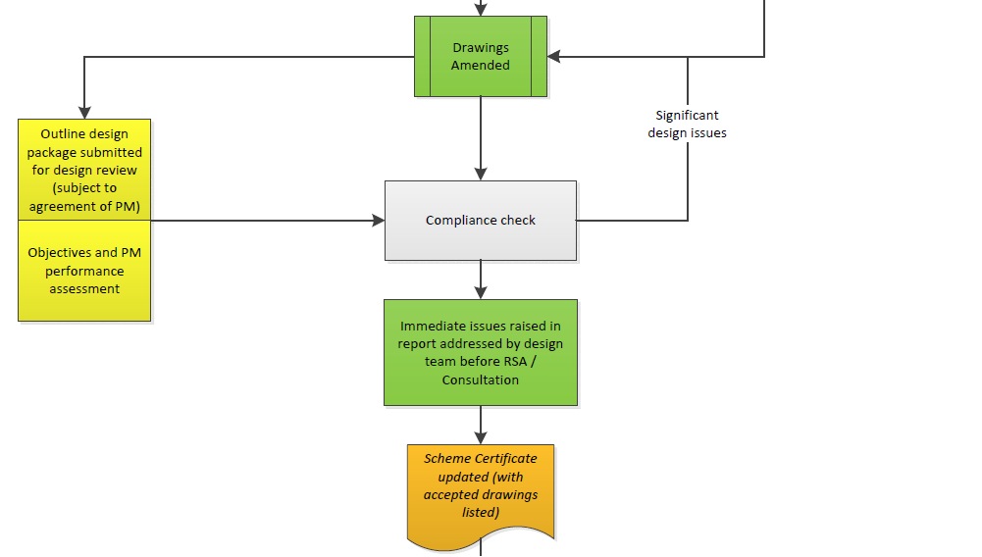

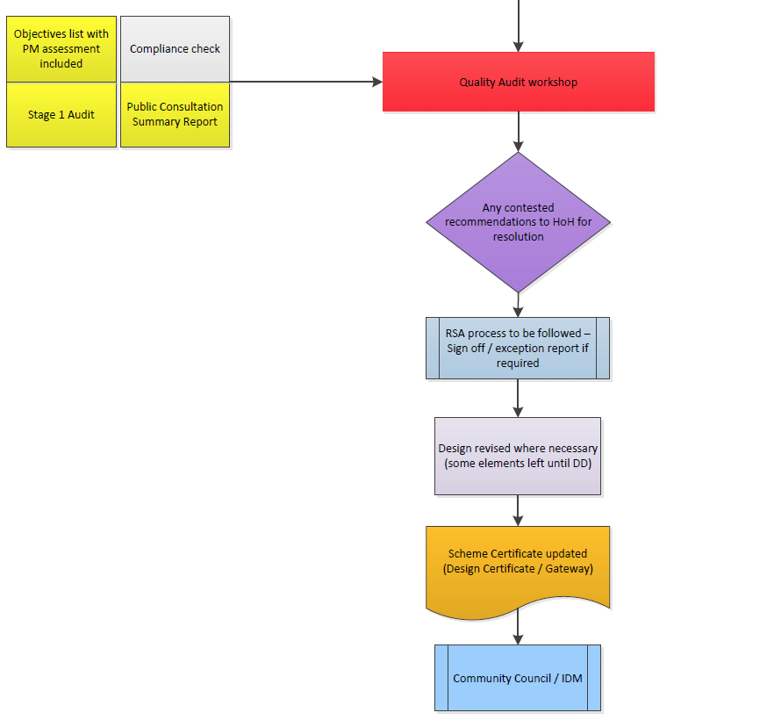

Appendix B Southwark Highway Scheme Pathway A Detailed Design Flowchart
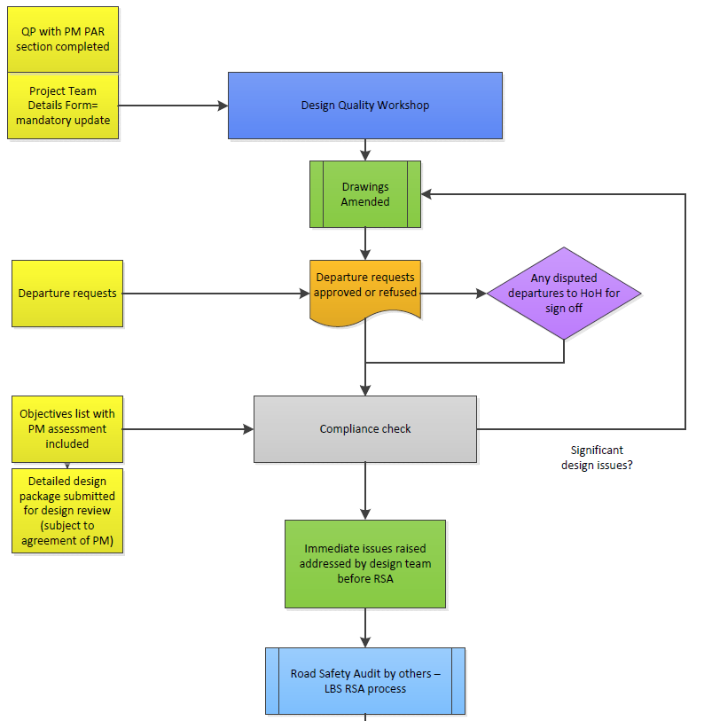

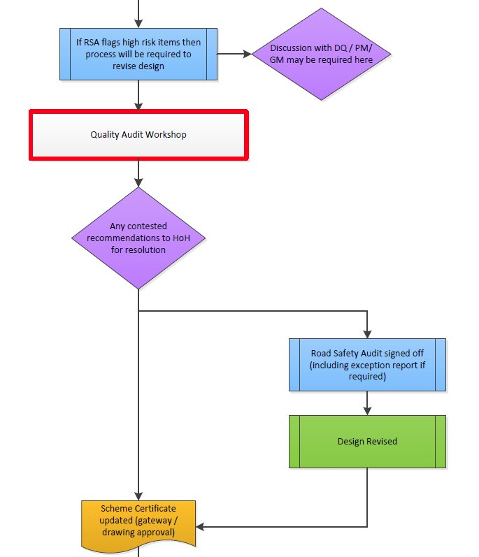

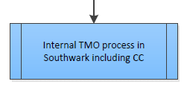

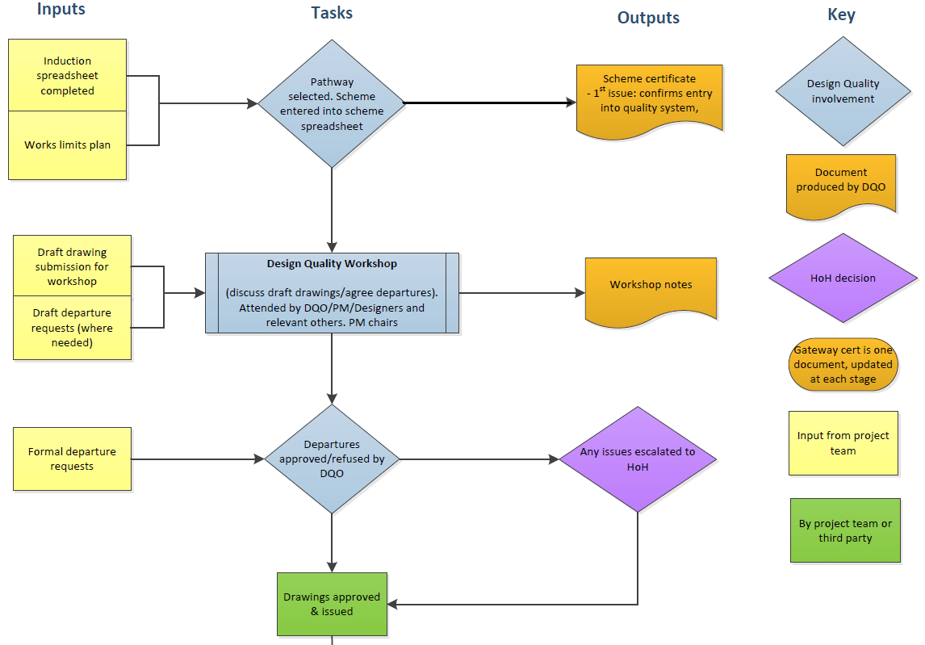
Appendix C Southwark Highway Scheme Pathway B Design Flowchart

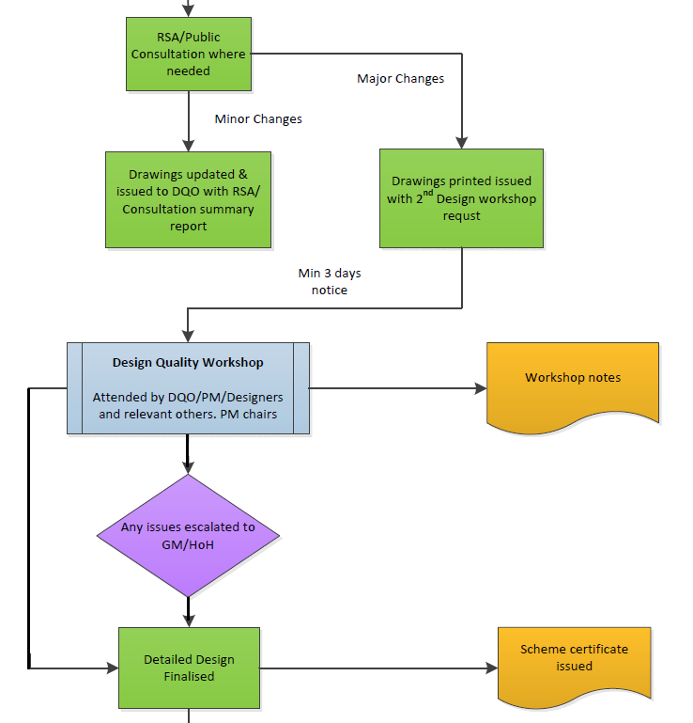

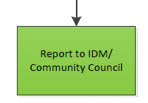

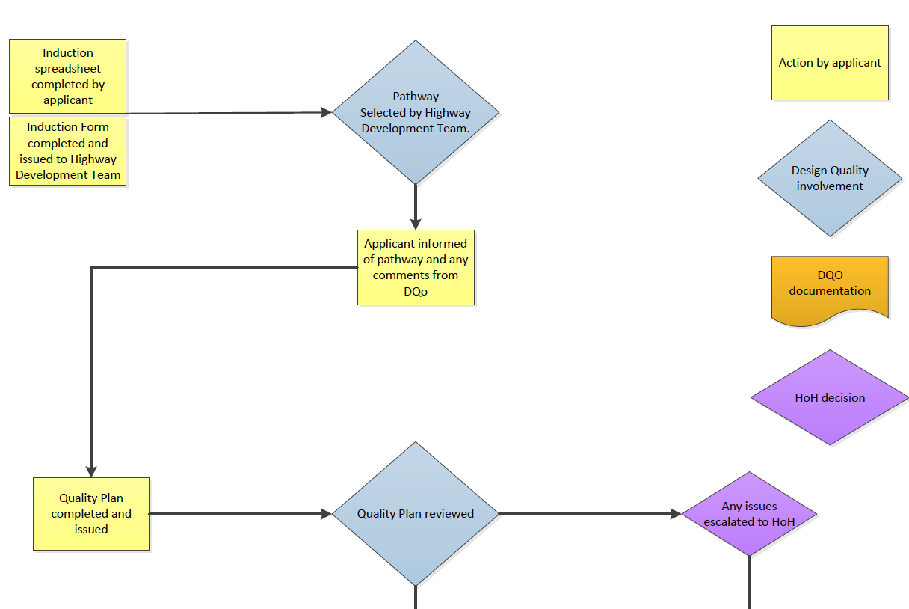
Appendix D Southwark Highway Scheme Pathway C Design Flowchart

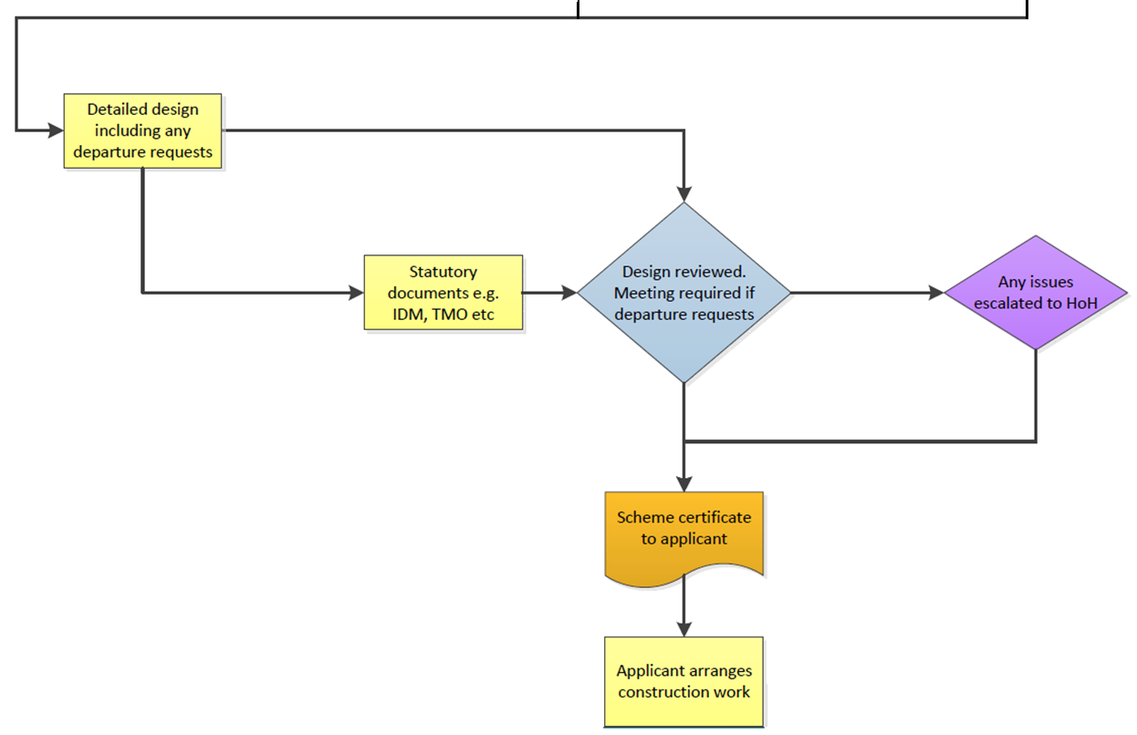

Appendix E Document Submission Requirements for all S278 and S38 Schemes

A completed ‘Section 278/38 Highways Act 1980 Application Form to enter into Agreement’.
- A drawing called ‘Section 278/38 Agreement’ showing the areas of highway and associated open space and shown coloured in the following manner:-

Ownership boundary - Solid red
S278 works boundary - Solid blue
Land to be adopted - Solid green with hatching
Easements - Solid plum with hatching
Carriageway - Grey
Footways and Footpaths - Yellow
Shared surfaces - Hatched Grey/Yellow
Cycle ways - Crimson
Paved Areas (not used by pedestrians
E.g. central reserves or traffic islands) - Burnt Sienna
Open or grassed areas - Green dotted hatching
Combined or Foul Sewer - Solid red ink line (fine)
Surface Water Sewer - Solid blue ink line (fine)
Gully connections - Broken blue ink line (fine)
Lamp column position - Brown circle
Street nameplate position - Brown cross
Tactile Paving - Buff (Controlled crossings: Red colour)

Drawings
To form part of each agreement, the developer will be required to provide a full set of drawings consisting of:-
- Site Location plan with red line (e.g. 1:1250 or 1:2500).
- Site clearance.
- General Arrangement plan (e.g. 1:500) including verges, visibility splays, plot boundaries, traffic calming features, building positions, garages and vehicle crossings, parking, trees, planting and landscaping, cross- section locations.
- Road construction details - typical sections.
- Longitudinal and cross sections at 5.0m interval - where necessary.
- Topographical survey with levels related to Ordnance datum – contours at 25mm interval.
- Highway drainage layout and calculations and any detail drawings.
- Details of any traffic calming measures.
- Details of street lighting, signs, road markings, traffic signals and other street furniture.
- Details of statutory undertakers alterations.
- Vehicle turning circle / swept-path drawings.
- Landscaping treatment.
- Setting out drawing
- Road markings and signs drawing.
- Pavement construction layout.

Documents
- Pre-construction site condition survey
- Requirements for any temporary or permanent traffic orders, permits or licences

Preliminary drawings and associated s278/38 documentation must be provided in full size hard copies, one set only (electronic copies can also be provided additionally). Once technical approval has been given, the developer will have to provide up to five hard copies of all drawings.

