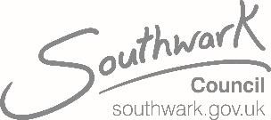

|  |  |  |
| --- | --- | --- |
| Newsletter | | |
|  |  |  |
|  | | |
|  | | |

**GOSCHEN ESTATE APRIL 2021 – ISSUE No. 6**

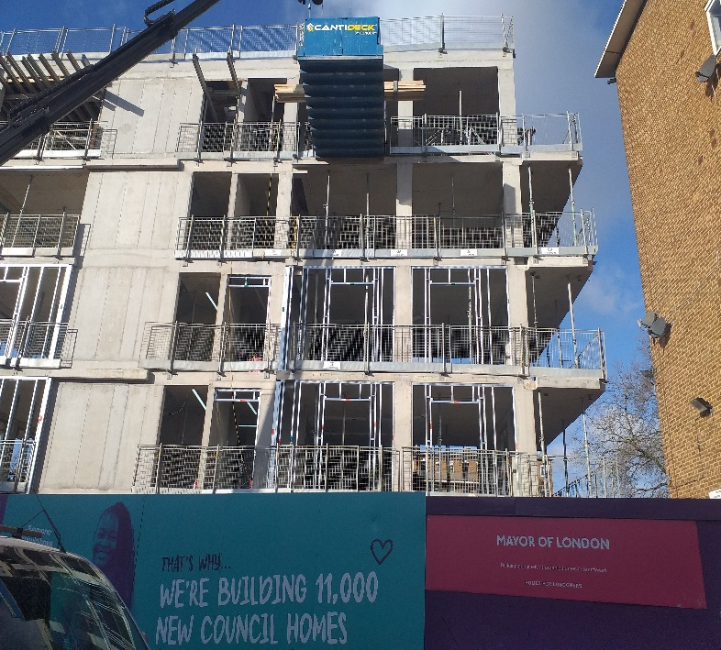

**WORKS PROGRESS UPDATE**

**The project is planned to complete in spring 2022**.

**Works Completed**:

* RC frame – (Reinforced concrete) frame has been built in the North and South block.
* Metsec - lightweight steel framing system that is typically installed instead of a traditional brickwork frame has been completed in the North and South.

**Works in progress:**

* Cement board fixing to north and south block
* Internal metal stud work setting out to north and south block
* Mechanical first fix. Plumbing fresh air / extraction ductwork – SVP (soil and vent pipes)
* Underground drainage

**Works Due:**

* External insulation
* Brickwork
* Electrical first fix.
* Window installation
* Ground floor screeding

**We are aware people are working from home, so we endeavour to keep the noise and disruption to a minimum where possible.**

INSERT PROJECT CGI

**RLO Contact Details**



**Guildmore, in partnership with Southwark Council.**

Delivering 17 new council homes:

North block- nine

South block - eight

**Site working hours:**

Monday – Friday: 8am to 6pm

Saturday: 8am to 1pm

**Name:** Charmaine Dullard

**Mobile:** 07811254355

**Email:** [charmaine.dullard@guildmore.com](mailto:charmaine.dullard@guildmore.com)

[rlo@guildmore.com](mailto:rlo@guildmore.com)

**GUILDMORE PROJECT MANAGER**:

**Name**: Keith Brady

**Mobile:** 07940657095

**Email:** [**keith.brady@guildmore.com**](mailto:keith.brady@guildmore.com)

**SOUTHWARK RESIDENT ENGAGEMENT OFFICER: Contact No**: 0207 525 2582

**Email:**NewHomesREO@southwark.gov.uk

**COVID-19 SITE SAFETY MEASURES**

Guildmore sites operating during the Coronavirus COVID-19 pandemic adheres to the Government guidelines to ensure the safety of all site staff and the wider community. The following is just a brief overview of the steps we have taken.

**Social distancing:** Staff maintain 2m social distancing wherever possible, including while arriving at and departing from work, while at work and when travelling between sites. Where a 2m distance is not possible we take further steps to mitigate risk. Signage is placed prominently at the site entrance and around the site. Essential meetings are held in the open air where possible or a well-ventilated room. The number of meeting attendees are limited to an absolute minimum.

**Hand washing:** Additional hand washing facilities are provided ensuring soap and fresh water is always available. Hand sanitisers are provided where additional washing facilities are not possible. Suitable and sufficient bins are provided for disposal of paper hand towels with regular removal and disposal. Signage is placed prominently at the site entrance and around the site.

**Personal Protective Equipment (PPE):** Suitable PPE over and above standard construction site PPE is provided in accordance with Government guidelines, including face coverings for site operatives.

**Site access controls:** No non-essential visitors are allowed and meetings are held remotely or virtually (Zoom, Teams etc.) where possible. We work to staggered start and finish times to reduce congestion and contact. All operatives wash their hands before entering and when leaving site. We do not have any access controls that require skin contact. All essential visitors and operatives receive a COVID-19 ‘Toolbox’ talk as part of their induction.

**Welfare facilities:** Werestrict the number of operatives using the toilets at one time. We have enhanced cleaning regimes and signage advising of the correct hand washing procedure.

**Canteen / Eating Facilities:** Break times are staggered to reduce congestion, and all operatives strictly adhere to social distancing rules. All staff are asked to bring in pre-prepared food and refillable water bottles. Additional hand cleaning facilities are provided and are used on entering and leaving the facility. There is enhanced cleaning after each use i.e., tables, freshwater tap, kettles.

**Changing facilities/showers/drying rooms:** Staggered start and finish times reduce congestion and contact. There is enhanced cleaning of facilities throughout the day. We provide suitable and sufficient rubbish bins with regular removal and safe disposal.

Guildmore are aware that the key to a successful contract is to fully segregate and protect the local environment, general public and adjacent buildings from the impact of the works – both visually and physically, from debris, dust, noise and vibration. The health, safety and well-being of those that we employ as well as the community is our highest priority. We will always comply with Central Government guidance on safe working protocols.