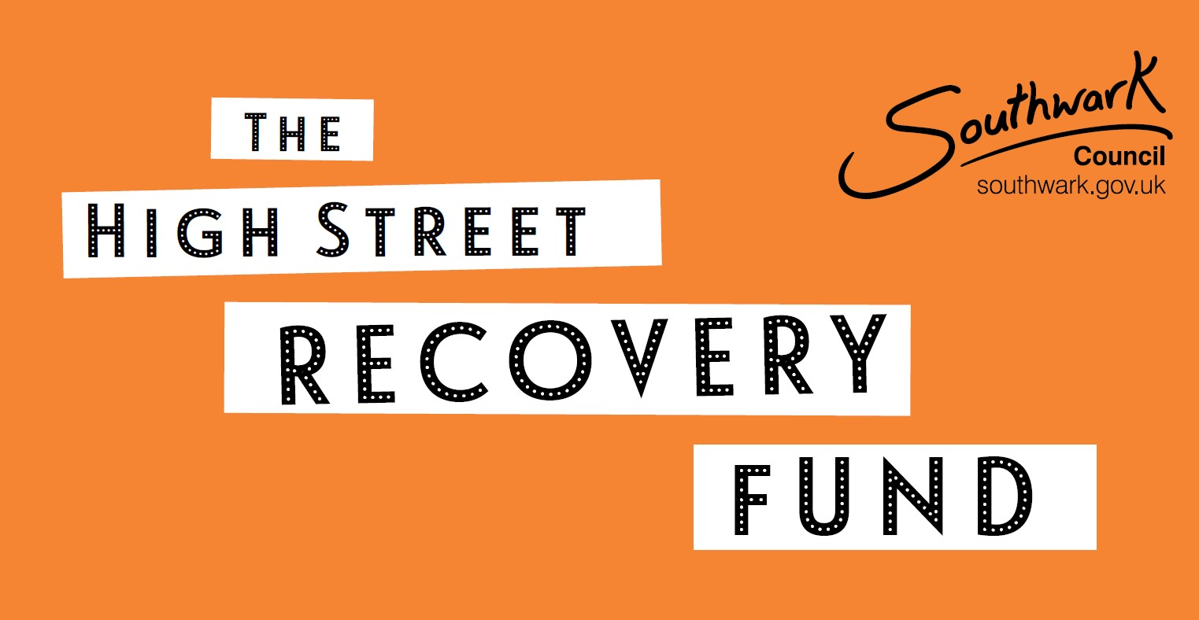

Application Form

Please submit your application by 5pm on

27 July 2021.

All sections must be answered. Answers cannot exceed the space available for each question.

To read the prospectus please visit www.southwark.gov.uk/highstreetrecoveryfund

Your organisation

Organisation name:

Organisation address:

Type of organisation (e.g. business network, individual business):

Telephone number:

Project manager:

Web address
(if applicable):

Email address:

Details of any funding received from (or committed by) Southwark Council in the past two years:

Your project proposal
How much are you asking for?
Over what timeframe will your project be delivered?
Summarise your project in 50 words

QUESTION 1 (25%)
What will your project do and how?
(Three pages available)
Check your answer for the following:
- Clear aims and objectives
- A detailed and convincing description of the delivery model (who will deliver what, where, when, and how?)
- Information on the benefits that will result from the project and how these will be achieved
- How the project fits in with the aims of The High Street Recovery Fund
- How your project brings an innovative or creative approach to its design or activities
- Why this is an improvement on what has been done before
- How the project supports high streets and town centres in the context of economic renewal and recovery from the Covid-19 crisis
- Details on how the project will help to generate follow-on activities in the longer term.
- Details of where your project will take place and the areas that will benefit

Outputs and outcomes (part of Question 1)
Please choose at least one outcome listed on page 7 of the prospectus, along with relevant outputs and explain how you expect your project to achieve them. Please also list any additional outputs and outcomes that your project will deliver. Please ensure they are realistic, proposing those that will best demonstrate the impact of your idea.

QUESTION 2 (25%)
How can you be confident that your project will be a success?
(Three pages available)
Check your answer for the following:
- An explanation of why you believe your aims, objectives, and outcomes are achievable
- Details of resources and support that are available to deliver the activities involved without day to day resources or management from Southwark Council
- Clear roles for each member of the project team and information on why they are appropriate for that role
- Details of any partnership arrangements including how funds, roles, and responsibilities will be divided
- Details of how the project will be managed and performance will be tracked
- Information on how you will manage the project’s finances
- An understanding of the risks involved and how you will prepare for and mitigate these
- Specific information (where, when, how?) on any similar activities that you have successfully delivered previously
- Any skills or experience held by members of the project team that are relevant to the project’s activities.

Milestones (part of Question 2)
Please provide clear, achievable milestones (key stages in the delivery of the project that will demonstrate progress).

QUESTION 3 (25%)
What will the impact of your project be, and why is it worth the funding that you are asking for?
(Three pages available)
Check your answer for the following:
- A breakdown of the project costs and justification for the main costs
- An explanation of how the project’s activities will benefit a large number of businesses
- An explanation of how the project will add value to existing activities in the area
- Clarity on how the project will continue to bring benefits to local businesses after the funding has been spent
- Details of any additional resources (e.g. match funding) that the project will bring to the area
- Details of the consideration given to crowd funding opportunities; i.e. will local residents or businesses be given the opportunity to financially contribute to the project
- An outline of how you will ensure your project will not have a detrimental impact of the environment

Budget breakdown (part of Question 3)
- Please provide a breakdown of your project’s costs below, including any match funding or crowd funding
- You can add additional rows if necessary, but your overall answer for this question must not exceed three pages.

QUESTION 4 (15%)
Why is your project needed?
(Two pages available)
Check your answer for the following:
- An understanding of local issues, needs, and demand.
- A clear rationale for the proposed project – why it is appropriate for the groups and geographical areas targeted.
- An understanding of existing activities in the area (e.g. regeneration programmes), and how the project might complement these.
- Evidence that existing business networks and local businesses are in support of the proposed activity.

QUESTION 5 (10%)
Southwark Stands Together is the council’s response to the inequalities exposed by COVID-19 and the events of 2020, as articulated by the Black Lives Matter protests.
How will you make sure your project reflects the key aims of this initiative and is inclusive and welcoming to all?
(One page available)
Check your answer for the following:
- Details of how your project will engage diverse local community and business groups.
- Explain how your project will promote inclusivity, particularly for low income and Black, Asian and minority ethnic communities.

SIGNED

NAME

POSITION

DATE

