Date: 7 July 2016 | Item  5 | Type of report: For information and decision
Report title: | 2015-16 DSG Outturn – Further Update
Author name  and contact details: | Mustafa Salih, Interim Senior Finance Manager
Officer to present the report: | Mustafa Salih, Interim Senior Finance Manager

Executive Summary

This report to Schools Forum is in response to the Schools Forum request for further information regarding the 2015-16 DSG outturn, in particular information regarding the 2015-16 DSG outturn:

- Further information regarding the reported SEN DSG overspend in 2015-16 of £1.24m
- An update on the use of the DSG reserves and the case to continue this funding strategy
- Proposals on how the 2015-16 DSG contingency of £2.92m could be utilised.

Action for the Schools Forum

The Schools Forum is asked to note this report and to agree in principle to the identified use of reserve funding beyond 2016-17. This would be subject to assessing the impact on future DSG allocations arising from government's proposed changes to the funding formula later this year.

1. Reasons for £1.24m DSG SEN 2015-16 Overspend

1.1 The budget for DSG SEN in 2015-16 was £14.342m and the outturn was £15.582m representing an overspend of £1.24m.

1.2 The main reason for the overspend was a significant increase in the number of placements during 2015-16 when compared with 2014-15. The Schools Forum were informed in January 2016 that there was a risk of a potential overspend of almost £1.5m therefore the outturn was slightly better than anticipated. The main causes were:

- £808k: Independent & Day Boarding variance was due to a sharp increase in placements for the 2015-16 academic year, most notably the ASD category of need from 130 placements in 2014-15 to 167 in 2015-16.
- Post 16 SEND is another significant growth area. Prior to September 2014, local authorities only had responsibility for SEND up to the age of 19 for those with eligible need. This has now increased to 25 years without any increase in funding

1.3 The Schools Forum were informed that funding for the High Needs Block has seen very little growth and the government’s expectation is that any SEND funding pressures are to be managed by Local Authorities from within their overall DSG allocation.

1.4 The charts below were presented to the January 2016 school forum and show the large increase in the more expensive independent placements in recent years contributing to the overall DSG SEN overspend. Since 2013-14 there has been a 40% increase in these placements.

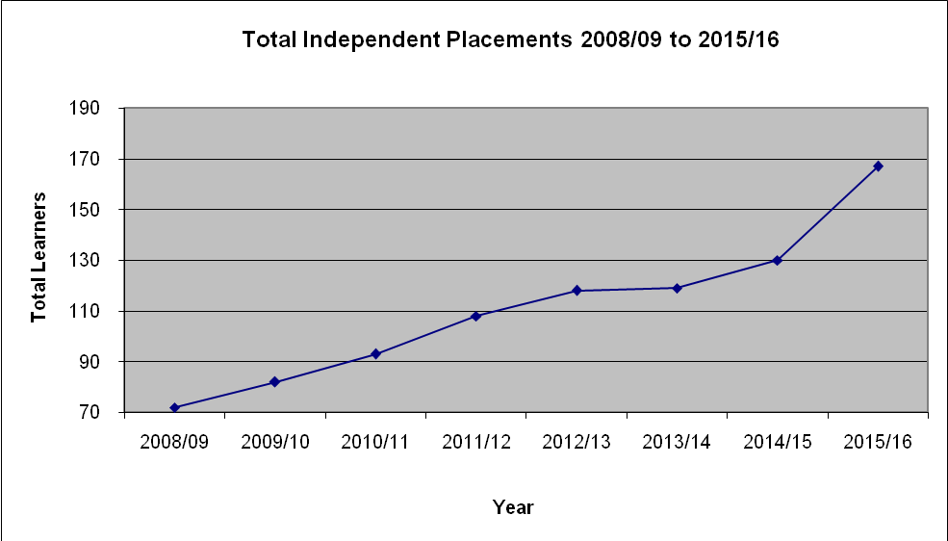

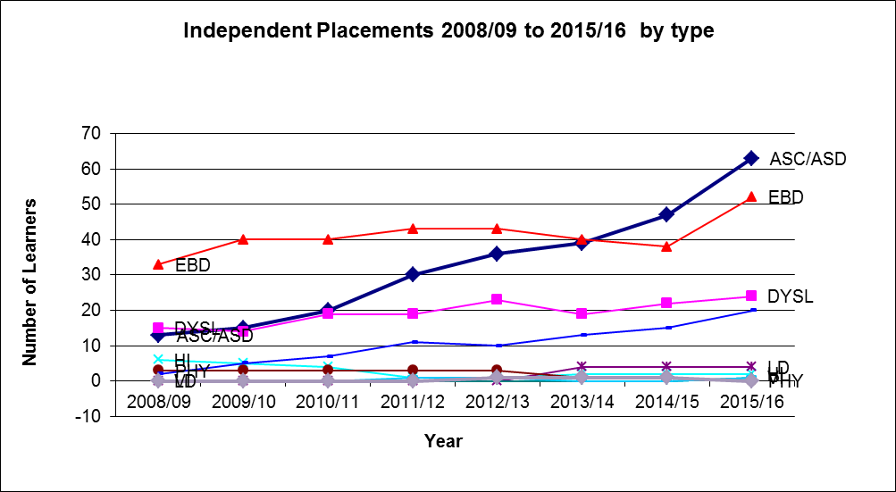

1.5 The biggest pressure area relates to Autism Spectrum Disorder (ASD) pupils, which is an area experiencing significant growth while at the same time there are very few vacant places within Southwark. When a pupil presents with ASD they usually have to be found a place in an independent or non-maintained school, which tend to be very expensive (upwards of £40k per year).

1.6 Post 16 SEND is another significant growth area. Prior to September 2014, local authorities only had responsibility for SEND up to the age of 19 for those with eligible need. This has now increased to 25 years without any increase in funding.

2. Use of DSG Reserves

2.1 The DSG reserves as reported to the May meeting are set out below followed by an update on the current position regarding their use and potential outcomes for children and schools.

Held as follows: | £m
Children’s and Families Act | 1.3 | Balance of £1.9m earmarked for future use at July 2014 Schools Forum. Funding requested to be continued to be held in reserve for use in 2016-17 for further programme of converting Statements to EHCPs.
Family matters | 0.5 | £360,000 for interim support for pupils in mainstream schools  £70,000 to increase capacity at Summerhouse  £70,000 to support a multi-disciplinary approach at SILS3  £50,000 for Cherry Gardens outreach support service.
SILS | 0.2 | Continuation of funding earmarked to increase capacity/quality of provision at previous Schools Forum meeting.
High needs contingency | 3.5 | To support Schools through High Needs Top-ups, Placement costs and other pupil related High Needs costs
Two year old funds | 2.1 | Agreed two year old funding ring-fenced to support future programmes including increasing capacity and support.
Total committed | 7.60
DSG contingency | 2.92 | Funding agreed to be held in reserves as contingency
Total uncommitted | 2.92
Total Funds held in reserve | 10.52

2.2 It is important to note that all DSG funding and resources are completely ring fenced. This means that that any reserves held can only be spent on schools’ budget items. Whist the items show above are current estimates of required spend, any underspend will remain in reserves and be presented to Schools Forum for alternative use on school budget items.

2.3 Each item is described in more detail below.

A. Children's and Families Act: Transition to EHCPs £1.3m

2.4 Transition to EHCPs is a statutory process that has to be completed by the end of March 2018 and this reserve is to support the transition process and associated costs. By the end of 2016-17 over 50% of the plans will have been completed, with another 750 remaining that will be completed within the timescale. A report will be published at the end of September on the local offer.

2.5 The process of converting statements to EHCPs is complex and resource demanding. It involves reassessment of each child's needs involving Educational Psychologists and other professionals meeting with parents, schools and the child.

B. Family Matters and Behaviour Support Strategy Funding and Outcomes £0.5m

2.6 In July 2015, Schools Forum agreed to allocate £500k of DSG reserve to establish interim funding for children who over an agreed period of time need some additional support in school in relation to behaviour. This funding was allocated as follows:

C. £360,000 Interim Support for Mainstream Schools

2.7 This funding was managed by the Early Help team, and during 2015-16 this was fully committed in payments made to schools. Details of funding allocations per school are set out in Appendix A.

2.8 Schools have been invited to apply for funding in situations where a pupil presents challenges beyond those that might be expected of behaviour and/or learning difficulties in a mainstream setting and it has not been possible to anticipate or plan for these challenges - for example in the case of pupil mobility or unplanned admission. Funding has been provided for a fixed period to enable assessment of a pupils needs and to support the reorganisation of schools support systems and resources accordingly.

2.9 These children may be going through the EHC planning process or may not actually meet SEN thresholds. This support is based on the premise that children with behavioural needs require help at the point of need and if left to wait until another placement is available or a plan is completed may have deteriorated and be at risk of permanent exclusions.

2.10 Most of the funding was allocated to provide one to one support to children with challenging behaviour for a limited period of time: a total of 38 individual children were supported in this way. These were difficult cases where there was a risk of schools permanently excluding children or of children not being admitted to schools. In several cases funding was provided for schools to develop their capacity to respond to high levels of complex behavioural needs.

2.11 Examples of children supported included:

- Year 5 child with a diagnosis of ASD previously subject to fixed term exclusion for violent behaviour towards other children. Support provided pending outcome of request for statutory assessment.

- Year 1 child, behaviour included ripping his teacher's jumper, breaking school property, disrupting learning and spitting. Consideration of child moving to attend special school, support provided pending outcome of EHCP submission.

- Year 3 child undergoing assessment at the Social Communication Clinic and very disruptive in class - at risk of exclusion due to his behaviour in school and towards his peers. Support provided while evidence was collected for an EHC application.

- Year 5 pupil moving from one to school to another, having suffered emotional trauma and exhibiting difficult behaviours. 1:1 support funded to support transition period. School reported that with this support, the child's ability to play happily and be considerate of others has much improved

- Year 2 child on child protection plan and being seen by CAMHS. At risk of exclusion due to extremely challenging and aggressive behaviour including punching, kicking and scratching adults and other children.

- Reception child self-harming by banging her head as well as destroying other children’s work, hitting, biting and throwing things at adults.

- Reception child with extreme behaviours including frequently damaging the classroom and becoming violent towards adults and other children. Support provided to prevent permanent exclusion, as behaviour was judged by school to be out of control and unsafe.

- Year 7 child with a diagnosed Coordination Disorder, physically aggressive with staff and students and had also walked off of the school site. Support provided while school collected evidence for EHCP application.

D. £70,000 to Increase Capacity at Summerhouse

2.12 Summerhouse provides a continuum of support in the management of pupils presenting challenging behaviours to all primary schools in Southwark. Summerhouse staff offer advice, guidance and support programmes to schools working with staff and children. Additionally, when more intensive intervention is required, places in blocks of two days-a-week are available on the Summerhouse site. Demand for these places has risen consistently:

- 2012-13 pupils on on-site roll: 48
- 2013-14 pupils on on-site roll: 46
- 2014-15 pupils on on-site roll: 58
- 2015-16 pupils on on-site roll: 70

2.13 Over the past two years there have been no available spaces for new admissions from before the end of the spring term. This has placed an increasing burden on mainstream schools in making provision for and assessing children presenting with challenging behaviours. This is particularly an issue in upper Key Stage 2 with the potential for a negative impact on the learning of other pupils approaching end of Key Stage assessments.

2.14 In response to this increasing demand the council has commissioned two new classrooms on the summerhouse site which will accommodate an additional 12 places. These classes will form part of the offer to primary schools from the start of the autumn term 2016. £70,000 will provide staffing for the additional places.

E. £70,000 to Support a Multi-Disciplinary Approach at SILS3

2.15 Southwark Inclusive Learning Service (SILS) provides statutory education for permanently excluded students in Key Stages 3&4. Student numbers develop during the year and places are available for up to 70 young people. Additionally SILS support schools in working with students on fixed term exclusions and offers preventative placements to minimise exclusions.

2.16 In 2015/16 SILS has had 17 students on dual/assessment placements from 12 Southwark secondary schools. None of these students have subsequently been permanently excluded.

2.17 SILS provides day 6 provision to pupils on fixed term temporary solutions. In 2015/16 118 learners were referred from across Southwark secondary schools. 104 students attended for a total number of 845 days.

2.18 A nurture group for pupils with complex emotional needs was established in the autumn term of 2015/16 funded by a DSG grant from schools forum.

2.19 Two external consultant reports have recently judged the provision to be particularly effective:
- At SILS 3 the establishment of nurture groups based on the primary model is proving successful and will be extended into the next academic year. Students are responding better in terms of behaviour to having fewer teachers.
- At SILS 3 in particular look at developing the nurture group approach more extensively. The environment of the nurture groups (both SILS 3 and 4) is working well and the team work demonstrated by the teachers and support staff promotes learning and the engagement of the pupils.

2.20 A continuation of last year’s funding would enable the necessary restructuring and staff development to expand the nurture group model.

F. £50,000 for Cherry Gardens Outreach Support Service

2.21 The Satellite Class is funded by a grant through Schools Forum:
- Based at Oliver Goldsmith Primary School pupils attend two sessions a week:
  - 2 x mornings (9.30am – 12.00pm)
  - 2 x afternoons (1.00pm – 3.00pm)
- Pupils who attend are on P-levels and are in Key Stage 2
- Focus is on literacy, numeracy, independence and social skills
- The class is for mainstream children with significant learning difficulties who need some specialist teaching to ensure they are reaching their full potential
- Activities are functional, motivating and appropriate to each pupil
- Teaching Assistants are given one hour per week to make resources to support pupils learning in the mainstream setting and to ensure their record keeping is up to date and next steps are identified for the pupil.

2.22 Ongoing training programme for Teaching Assistants focusing on:
- Makaton (signing)
- Using symbols to support learning
- Communicate: In Print
- Observations
- Record keeping
- Encouraging verbal communication
- TEACCH.
- P-level assessment
- Modelling of how to use symbols and sign to aid learning and understanding.

2.23 In 2015-16 35 children attended the satellite provision from 21 Southwark schools. The satellite provision support:
- Helped develop the provision for learning difficulties in the mainstream schools
- Ensured that these vulnerable young people made good or better progress
- Sustained their chosen option of a mainstream school place in line with parents’ wishes
- Enabled significant savings to be made from the High Needs Block as special school placements for these children would cost between £30,000 and £50,000 per child, not including transport - these places would have to be outside Southwark.

G. Behaviour Support Strategy

2.24 This report summarises how the additional £550,000 of DSG funding has been used in 2016-17 across the four initiatives. Later this year an update will be provided to Schools Forum on how this investment has improved the outcomes for children. Officers believe the case to continue funding remains strong and informed by the update report Schools Forum can consider whether to continue funding beyond 2016-17. This would be subject to the impact on future DSG allocations arising from government changes to the funding formula following completion of the DfE’s consultation process later this year.

H. High Needs Contingency £3.5m

2.25 Some of the pressures leading to the 2015-16 overspend continue to exist in 2016-17 leading to another budget pressure which is currently forecast at £1.6m. In addition the development of a short to medium term strategy will require funding that will:

- Reduce the dependency on expensive out of borough provision
- Support the development of additional top up bands for mainstream provision

I. Two Year Old Funding £2.1m

2.26 The reserve of £2.1m will continue to support the take up of places but owing to a longer time lag and fewer than anticipated numbers the use of this reserve is currently under review. Any funding here that is not required for two year old expenditure would be available to support any funding shortfall arising from the current proposed reforms to the early years funding and the developments regarding extending the free entitlement to 30 hours a week for eligible working parents.

3. Allocation of 2015-16 £2.92m DSG Contingency

3.1 Background

3.2 The 2015-16 DSG outturn was reported to the May Schools Forum meeting and within the total of funds held in reserve of £10.52m was an unallocated contingency of £2.92m. Officers were asked to develop proposals for how this funding could be allocated to schools

3.2 As set out in the outturn report officers are keen to ensure that funding from the DSG reserve is being allocated to schools on a prudent approach in response to continued uncertainty and risks to future school funding. Any allocation is a one off use and should not create a recurring expenditure commitment on school budgets and the use of this funding must be considered in the context of the current education and school funding environments. In addition to these challenges there are a number of factors that impact upon the allocation of the DSG contingency namely:

- Risks associated with further reform of school funding, including a potential national funding formula and ongoing review of early years and high needs funding arrangements
- Support for individual schools experiencing financial 'shocks' including pupil number reductions and formula changes.

3.3 There are a number of short to medium term financial risks that can be mitigated through the careful and considered use of the DSG reserve. As indicated above, a significant risk is the as yet unknown financial impact of the introduction of a national funding formula and the contingency could be used to help cushion the transition to the new formula. External commentary on the proposals in the Spring suggested council's like Southwark could lose up to 10% of their schools block funding.

Proposals

3.4 Officers have identified proposals for utilising the DSG contingency in the table below.

Proposal
Extend transitional relief arising from funding reforms

Uprating of EHCP banding rates

Introduction of additional SEN top up bands
Increasing deprivation funding

Uprating EHCP Costs

3.5 The allocation of SEN top up funding is determined using a spreadsheet, or ‘Ready Reckoner’, that costs the care plans proposed by the writers in consultation with schools. Current work involves updating the ready reckoner for increases in current pay scales and employers overhead rates arising from increases in NI and pension contributions. At a recent briefing on the new national funding formula experts predicted these increases will add between 3% to 6% to schools’ employment costs.

3.6 This would create new funding pressure of around £200,000 excluding any growth in the number of EHCPs. Officers believe a prudent provision from the contingency would be £250,000.

New SEN Top UP Bands

3.7 Current SEN funding for maintained schools involves:
  - Schools meeting the first £6,000 of cost from their ISB; plus
  - Top ups from the High Needs Block using two bands;
  - Band 4: £12,715
  - Band 3: £15125.

3.8 At the May meeting SCHOOLS FORUM were updated on a SEN funding formula review group that will develop additional top up bands on a more progressive basis so that the gap between the first £6,000 and Band 4 is less severe. The review is also looking at additional financial support for schools with disproportionately high numbers of children with EHCPs.This is on-going work and a report will be presented to SCHOOLS FORUM in the autumn with costed proposals. The DSG contingency could prudently be used to support transition to any agreed changes to SEN funding arising from the review.

Increased deprivation funding

3.9 It would be possible to redistribute all or some of the £2.92m by increasing the deprivation measures used in the formula for determining the school budget shares. For example this funding would allow the FSM formula rates to increase the per pupil funding rates from £1,326 to £1,396 for primary schools and from £1,411 to £1,661 for secondary schools, an increase of £2,700 for FSM pupils.

3.10 The Financing of Maintained Schools Regulations do not allow school budgets to be amended in year so this option would only be available for 2017-18 financial year.

Appendix A: use of £360,000 interim support for mainstream schools

School | Amount £ | Purpose of funding
Ann Bernadt | 9,000 | Support for one child.
Charlotte Sharman | 18,319 | Support for five children
Comber Grove | 18,157 | Support for two children, plus package of support from Kintore Way
Dulwich Wood | 9,430 | Support for two children
Globe Academy | 6,880 | Support for two children
Grange Primary School | 4,867 | Support for one child.
Heber Primary School | 4,560 | Support for one child
Hollydale | 41,561 | Support for four children
John Donne | 3,000 | Support for one child
John Ruskin | 6,108 | Support for one child
Keyworth Primary School | 29,000 | Support to reshape SEND provision
Kintore Way | 29,000 | Support for additional capacity
Oliver Goldsmith | 31,443 | Support for four children
Pilgrims Way Primary School | 28,115 | Support for one child + transport
Riverside Primary School | 1,840 | Support for one child
Rye Oak | 50,000 | Start up funding for LSU
Snowsfields | 13,832 | Support for two children
St James C of E | 11,387 | Support for one child
St Johns & St Clements | 8,220 | Support for one child
St Judes | 6,000 | Support for one child
St Pauls CE School | 13,891 | Support for three children
St Thomas the Apostle | 9,834 | Support for one child
Surrey Square | 5,151 | Summer playscheme for three children
 | 359,595

