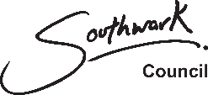
No Recourse to Public Funds

Supporting documents

(May 2017)

The following documents will be useful in supporting your/your client’s request for support from Southwark Council

Documents
Passport (applicant)
Passport (other adult in household)
Passport/s (children)
Birth certificate (applicant)
Birth certificate (other adult in household)
Birth certificate/s (children)
Letter from Home Office
Letter from solicitor
Marriage certificate
NHS GP registration cards
Personal child health records (sometimes called a “Red Book”)
Letter from hospital
Letter from child/children’s school
Payslips (last six months)
Entitlement letters for benefits
Current account statements (last three months)
Savings account statements (last three months)
Credit card statements (last three months)
Loan statements (last three months)
Mobile phone statements (last three months)
Proof of address (utility bill etc)
Proof of previous addresses
Tenancy agreement
Eviction letter

