Lets have a conversation about damp and mould
Most people experience damp/mould in their homes at some point. We want to work with you to solve the problem so you can go on enjoying your home.
The first thing we’ll do is arrange for our team to visit you and treat the mould you have. You should already have an appointment with us, if you haven’t our contact details are further along in the leaflet. We might leave a dehumidifier with you when we come but we’ll talk that through with you.
Treating the mould is done in three stages. The first stage cleans the surface and kills all visible signs of mould. The second stage forms a barrier to prevent mould re-infecting the surface and the third stage is an anti-fungal decorative finish. Depending on the amount of mould you have it normally takes us either half a day or a full day in your home to finish the treatment.
When we’re there we’ll have a chat with you about what causes mould, how the council can work with you and have a look around to see if there is anything else we can do to fully resolve the issue.
Once we’ve treated the mould our team look at the pictures we’ve taken (before and after the treatment) and we look at other things like where you’re getting mould and how often you’re having a problem.
Most of the time this treatment and our chat is all it takes for mould not to be a problem again. Sometimes we’ll need to do some more work to your walls or we might want to install a fan or extractor system as well. If we do we’ll give you a call after the treatment to talk to you about what we want to do and why and to arrange a time with you to come and do it.
You’ll always get a call from us about a month after our first visit just to check that everything is ok and that what we have done worked. You can have a chat with us when we call you if you have any concerns or want any advice about mould or what to do if it comes back again.
Advice
There are some things you can do to help manage moisture in your home which will help stop mould forming. The average family produces up to 17 litres of water vapour a day!
- When you’re cooking be sure to open a window or use extractor fans if you have them
- Drying clothes outside is always better, if you don’t have that option dry clothes in a well ventilated room away from walls
- Don’t cover up any air vents or extractor fans you have, they are there for a reason to keep air flowing
- Always try and keep a gap between furniture and walls, when you push something against a wall it doesn’t allow any air flow and you can get mould growth
- Keep a balance between heating your home and opening windows and vents
We know that you have a life to live in your home and we never want you to feel like you’re being blamed for damp. Damp is something most people experience at some point and we can always do something with you to stop it.
We know that sometimes you’ll need to dry clothes inside or that you’ll be cooking big batches or food, that’s part of life. With this pack we’ve included a hygrometer, it measures the amount of moisture in your home. If the arrow is on blue you’re at risk of mould growth and you’ll need to open some windows to let some air circulate. If that’s happening a lot let us know and we can visit and see what we can do to help.
The picture below shows you what the different colours and numbers mean
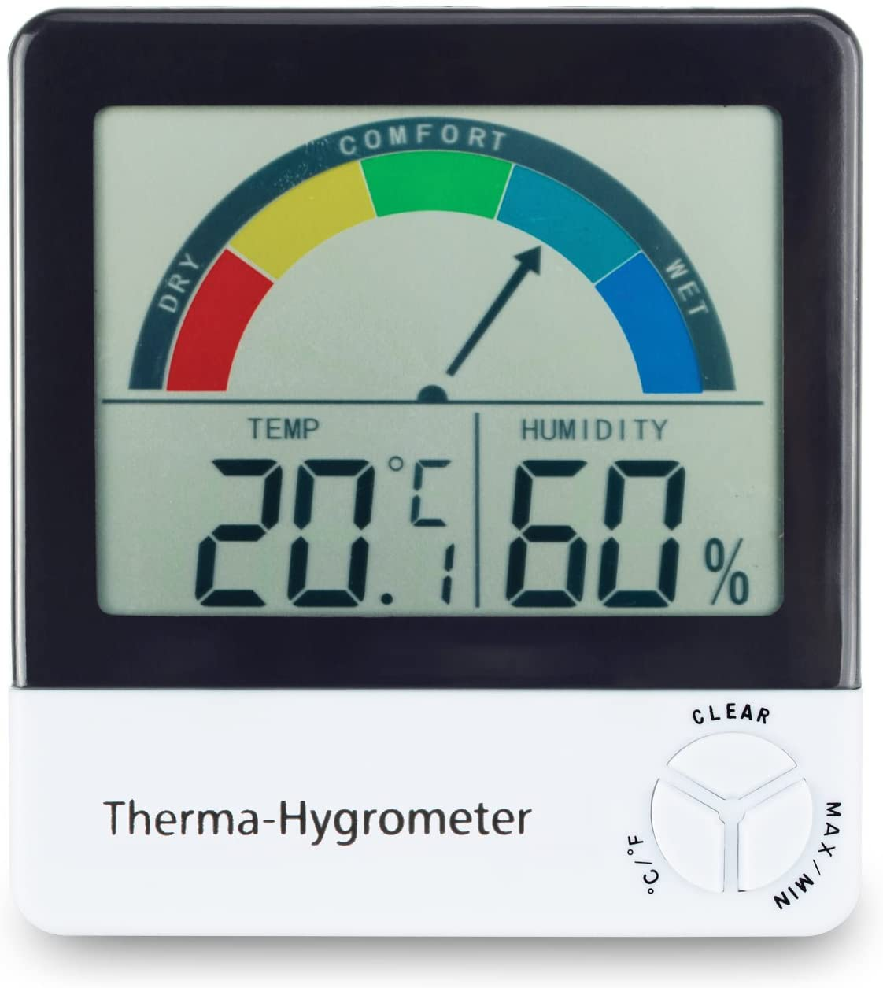

We’re always here to talk about damp and mould
You can always contact us when you need to, you might want to tell us the problem has come back or you might want a chat about mould and how we can help. You can call us 9am to 5pm Monday to Friday 0800 952 4444 and choosing options one and then option five or emailing us at repairs@southwark.gov.uk.

