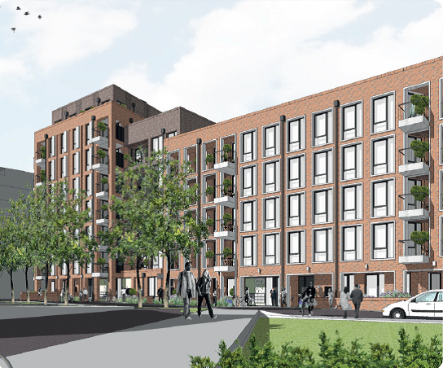

# **Copeland Road update**

|  |  |
| --- | --- |
|  |  |

## **October 2019**

## **Your quarterly update about the development of new homes on Copeland Rd**

**What you need to know:**

We’re creating new homes on Copeland Road as part of our commitment to providing more quality council homes across the borough. We’ve committed to building 11,000 new council homes by 2043 – a big goal, but crucial if we’re going to tackle the housing crisis and ensure our residents have quality homes they can be proud of, now and in the future.

We’re building 67 one, two and three bed flats at Copeland Road. Twenty four of these homes will be for council rent, eighteen will be let on affordable rents, and twenty five will be for private sale.

These new homes will be built on the former Copeland Road carpark site. Of these:

* 50% of the council rent homes will be prioritised for local residents who are on the waiting list and in housing need, so they can continue to live near family, friends, and services they currently use
* 50% of the council rent homes will be allocated to people on our wider housing waiting list
* 10% of these homes (seven units) will be built to mobility standard

A key priority for us in creating new homes at Copeland Road is to make improvements to the whole estate so everyone can benefit. This includes:

* Landscaping the existing green area to Hazel Close
* Repaving the footpath at the Copeland Road entrance
* Repaving the footpath at the Bournemouth Close entrance
* Improving the zebra crossing at the Copeland Road entrance
* Rebuilding the basketball court

**Timeline**

**July 2019** Main construction works begin

**November 2019,** Community meetings with the contractor, ward members and local

**March 2020,** stakeholders

**July 2020,**

**November 2020**

**February 2021** Expected completion date

**Meet the Contractor**

You are welcome to come along to a meet the contractor drop in session to discuss any concerns and the project as whole on the 7th November from 6.30pm to 8pm. Please let Evelyn Thomas (details at the bottom of this newsletter) know if you wish to attend.

**Latest updates**

We’re working on plans to build a small playground for children on the ground floor.

The existing basketball court will be upgraded and improved, including new noise reduction measures for residents living near the court.

We’re going to build shared spaces all residents can enjoy, including a sitting area on the ground floor and a shared roof terrace.

The new homes have been designed to prevent overshadowing and overlooking neighbouring homes, and should look like this:

 

**Working with you**

It’s really important to us that we work with residents when we create new homes in Southwark.

We’ll arrange quarterly monthly meetings where you’ll have the chance to get updates and give us any feedback or questions. We’ll let you know ahead of time when each one is due to take place and details will be uploaded to the website at least two weeks in advance.

We know that changes in your neighbourhood can be unsettling and we’ll continue to keep you updated and answer your questions as the project continues.

**Your views**

Here are some of the queries and concerns you’ve recently raised:

**The contractor site boundary has been widened without the council’s permission**

We’ve looked into this and have found that Purelake did not exceed the permitted boundary.

**There is inadequate lighting to the site hoarding**

Initial issues with the lighting to the site hoarding have been fixed and it is now fully operational.

**The site hoarding has darkened alley ways**

Purelake have installed another CCTV camera which monitors the area next to the site’s hoarding.

**Your contacts**

**Contractor site manager:**

Scott Parker - available on site, Mon-Fri 8am - 4pm and Sat 8am - 1pm

Scott can help you with any questions you might have about day to day onsite activities.

**Purelake New Homes contractor:**

Donald Muir, Development Surveyor - donaldmuir@purelake.co.uk / 020 8313 6833

Donald can help you with any questions you might have about the proposed works or about Purelake New Homes.

**If you’d like to know more about this project:**

Evelyn Thomas, Project Co-ordinator - Evelyn.Thomas@southwark.gov.uk / 020 7525 1643

**Find out more at:** **tinyurl.com/housing-copeland**