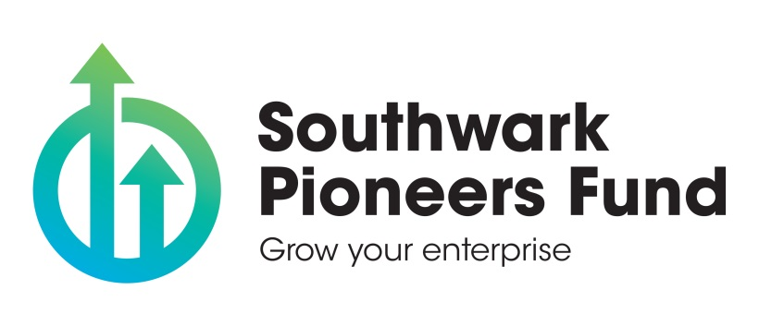
Southwark Pioneers Fund: Grants (Round 1)

Guidance notes

Please read this information carefully and in full before completing the application form.

These guidance notes provide details on how applications will be assessed and what to avoid when completing the application form. The notes also provide information about the structure and the processing of successful grants.

Applicants will be referred back to these guidance notes if the information sought is contained within this document. However, applicants are encouraged to contact us for clarification on points unanswered within the guidance notes.

- Southwark Pioneers Fund

Southwark Council is launching a new grants programme as part of its Southwark Pioneers Fund support for entrepreneurs and small enterprises, in October 2019. The Fund’s support will be delivered in phases, and this is the first phase of its support. The grants programme will focus on delivering social value outcomes for residents as set out in this guide.

Southwark Pioneers Fund grants of up to £5000 are intended for enterprises and entrepreneurs who may be piloting, testing and experimenting with new/innovative solutions, and/or at an early stage in their growth journey.

Applications will open on Monday 28 October 2019, and they will close at 9am on Monday 25 November 2019.

- Eligibility

We will only accept applications from organisations or individuals that are constituted, limited, a registered charity or under any other legal structure for an organisation e.g. Community Interest Companies (CIC).

You must also meet other eligibility criteria as set out in the application form (at page 2).

In order to enable the Council to prioritise applications, applications are assessed against the grant programme priorities and the information provided on your application form.

- What we do not fund

• Political activities
▪ Duplication of projects / activities
▪ Items purchased/unspecified expenditure prior to grant application
▪ Activities that do not align with our Southwark Council values

- What you need to include within your application regarding social value
The decision to award funding will involve (in part) assessment of the following criteria (at question 5, Part D of the application form):
- Likelihood of job creation:
- Do you think this grant support will help your enterprise create jobs either within your enterprise or for Southwark more generally? If so, how?
- Likelihood of the creation of other social value outcomes (outcomes that contribute to benefits to society, the economy and the environment)
- How does or could your enterprise contribute towards our Council Plan Commitments (for example towards reducing crime, reducing childhood obesity, and other areas that matter to residents.)
- Does or could your enterprise contribute towards one or more of our Common Purpose Outcomes? If so, how?
- If you plan on employing people (now or in the future) what are your plans for promoting Southwark as a London Living Wage borough?
One of the Fund’s primary aims is to widen the diversity of those who own and start up enterprises and charities in Southwark. For this reason, we are asking for equalities information about whether you are female, from a BAME background and/or have a disability.

- What you need to include in your application regarding proposed expenditure
You must provide details of what you propose to spend the grant on (if successful) using the application form’s table (at question 3, Part D).
We will assess the financial information based on the following principles:
• The level of detail and clarity in the budget breakdown and how expenditure relates to proposed activities
• Value for Money e.g. hourly rates and sessional fees compared to market rates, admin costs proportionate
• Correct calculations (does it add up correctly?)
• Is it realistic and achievable?
• The need to keep within the overall budget for this grants round.
- Submitting your application
The closing date for applications is Monday 25 November at 9am. Applications received after this time will not be assessed.
Applications must be completed in full and require signatures from the Director/manager of your organisation.
Please be reminded that we can only accept applications from organisations or individuals that are constituted, limited, a registered charity or under any other legal structure for an organisation. We cannot make payments into personal bank accounts.
- Things to avoid
We are interested in what you propose to spend your grant on (and why), and the value that you think this grant can generate not only for your enterprise but for Southwark residents. You should avoid:
▪ Providing lengthy information on the background of your organisation
▪ Using statistical information; if it is necessary keep it brief
- Notification
Applicants should be notified of the outcome of their proposal during January or February 2020.
All successful applicants are required to abide by the council’s Conditions of Grant Funding (COGF).
Funded organisations are monitored to ensure these conditions are being complied with and to ensure outcomes are being delivered.
- Timetable of dates
Stage | Date
Programme opens for applications (Round 1) | Monday 28 October 2019
Programme closes (Round 1) | Monday 25 November 2019
Organisations notified of recommendations | Late January 2020 / February 2020
First grant payment made | April 2020

- Supporting documents
Don’t forget to attach the supporting documents listed at Part C.

- Submitting your application
Please email your signed and completed application to southwarkpioneersfund@southwark.gov.uk or post it to:

Southwark Pioneers Fund
Local Economy Team
Southwark Council
PO BOX 654529
London
SE1P 5LX

by 9am on Monday 25 November.

Applications received after this time will not be accepted (although please bear in mind there will be further funding rounds for this grants programme).
If you require any advice or help with completing your application form, please contact us at southwarkpioneersfund@southwark.gov.uk.

