Equipment and gadgets

Image | Equipment
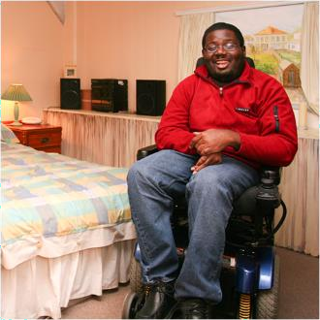 | Some equipment can help you to live independently at home if you have:  - a physical disability  - a learning disability  - problems getting around
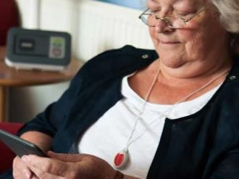 | This equipment also known as telecare includes the following:
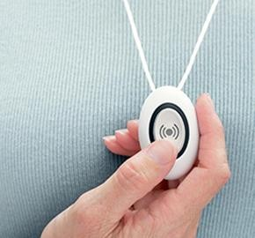 | an alarm pendant is worn around the neck or wrist. Help arrives at your home if you press a button on the pendant.
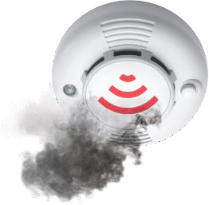 | Sensors – an alarm will sound if:  - there is a fire or smoke
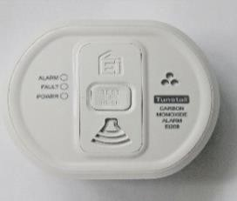 | - there is a gas or carbon monoxide leak
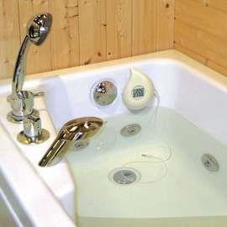 | - sink or bath overflows.
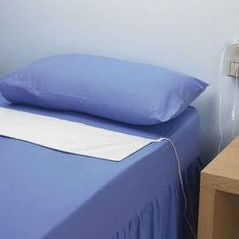 | A fall detector, bed sensor and epilepsy sensor  This equipment calls for help if you have a fit or fall over.
 | Some equipment can tell your family or friends when you fall or get out of bed.
 | Equipment for daily tasks
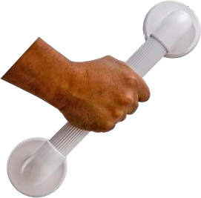 | - bath board and grab rails in the  bathroom can help you to get safely in and out of the bath.
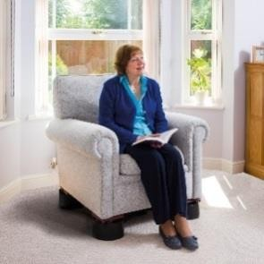 | - chair raisers can help you to sit  down or get up from your chair.
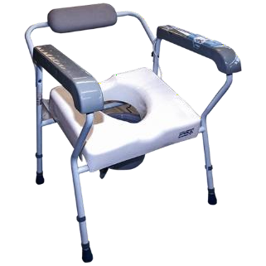 | - raised toilet seats and commodes can help you to use the toilet.
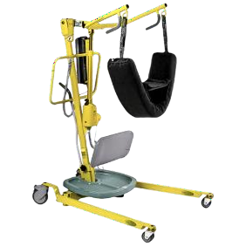 | - hoists, specialist beds and chairs help you to get around at home.
 | - forearm supports and stabilisers to help you eat
 | - medication dispensers give you reminders that can be seen or heard so that you take medication at the right time.
 | Equipment for people with dementia
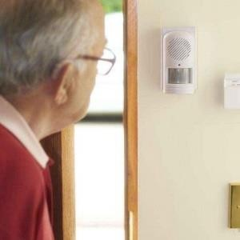 | - memory aids such as memo minders play messages out loud to remind you to take medication or eat meals.
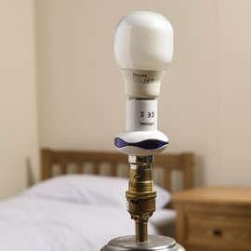 | - a device that turns the bedroom light on to help you if you need to get out of bed at night time
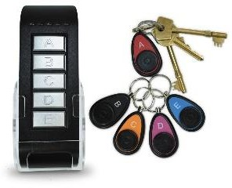 | - a key reminder device reminds you to take your keys with you when you leave home
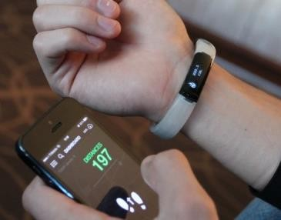 | - a safer walking device to help you get home.
Where to buy equipment

You can buy this equipment from many shops, such as:
 | Age UK
 | Careline 365
 | Living Made Easy
Telecare equipment

Telecare is equipment linked to 24- hour call centres where trained staff
can contact:
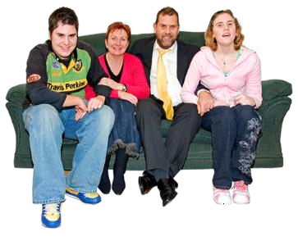 | - your family
 | - emergency services if they need to
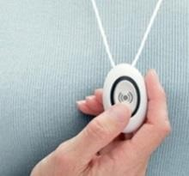 | You can buy telecare from:
 | Living Made Easy
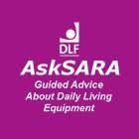 | AskSARA
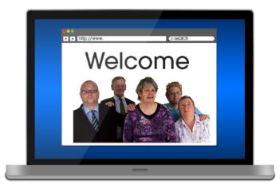 | TelMeNow – is an website that helps  you find the best equipment
 | We will carry out an assessment (for more information go to our can we help with your care and support needs page if you would like to find out if you need to pay for telecare.
 | You could pay up to £5.75 every week.
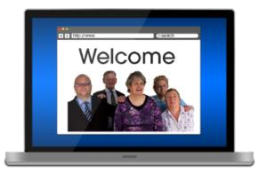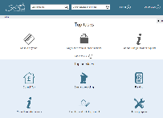 | For more information go to our Paying for your care page
BBefore you buy equipment

It is a good idea to get independent
advice to check that the equipment meet your needs.
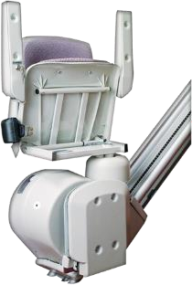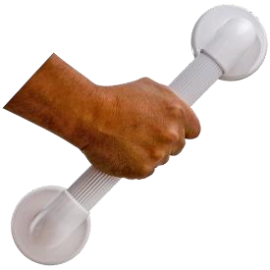 | MMaking it easier to live at home  You could make it easier to live  independently at home by fitting, for example:  - a stair lift  - grab rails
You can get a local tradesperson to do
this work (not stair lift) or contact the Southwark Handyman service.
 | The Handyman service can help you fit small adaptations at home.
Information and support

Southwark Disablement Association (SDA) provide information and advice for people with:

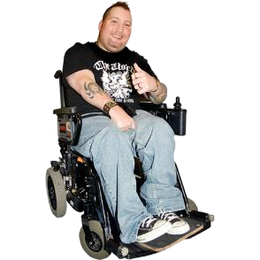 | - a physical disability.
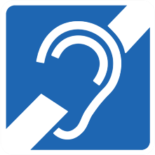 | - hearing or sight problems.
 | NHS Choices provide a Guide to Care Equipment, Aids & Adaptations.
 | Turn2us provides information on grants to help you buy equipment.

